Assignment 2
Data Management (INFO125)
Deadline: Friday, 27.09.2024 at 13:00
INSTRUCTIONS: To be completed in groups of 1-3 students. The assignment is mandatory for all students of INFO125 and should be submitted on Mitt UiB. Please note that questions about the assignments or group seminars should be directed to your seminar leader (TA).
- For the binary relationships below, suggest cardinality ratios based on the common-sense meaning of the entity types.
ENTITY 1 CARDINALITY RATIO ENTITY 2
1 | Pilot | 1:N | License
2 | Airport | 1:N | Airplane
3 | Children | N:1 | Mother
4 | Order | N:1 | Customer
5 | Manufacturer | 1:N | Product
6 | PizzaSize | 1:N | PizzaOrder
7 | Doctor | 1:N | Patient
8 | Tourist | N:M | Country

- 1. One pilot can have one or many licenses.
- 2. One airport can have many planes, but an airplane can only be at one airport at a time.
- 3. A mother can have multiple children, but the children only have one mother (if they are all siblings.)
- 4. A customer can have many orders, but an order belongs to one customer
- 5. A manufacturer can make multiple products, but a product only comes from one manufacturer.
- 6. The size of a pizza can be on one order, or multiple orders.
- 7. A doctor can have one or more patients.
- 8. A tourist can visit multiple countries, and a country has multiple tourists.

- Consider the ER diagram in the following Figure for part of a Football database. Find the answer to the following:
  - List the strong entity types in the ER diagram.
    - Player
    - Country
  - Is there any weak entity type? If so, give its name, and its identifying relationship.
    - “Club” is the weak entity type, its identifying relationship is “in”.
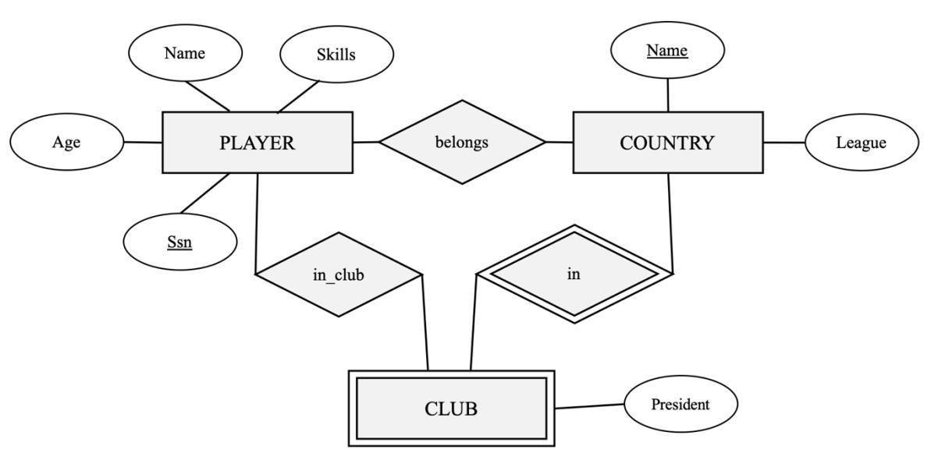

- Draw the ER diagram for the following mini-world:
  - Music companies keep data about each MUSICIAN, such as the name (which is unique), birthplace, birth date, and music genre.
  - In addition, the pieces of MUSIC produced by the MUSICIAN are stored. For each piece of MUSIC, the production year, the unique title, the genre (e.g., Pop, Rock, Jazz, Blues), and production cost are stored.
  - Companies also keep data about each ALBUM which typically contains several pieces of MUSIC. A unique name identifies each ALBUM.
  - Finally, music companies keep data about each CLIENT, including a unique client ID, name, address, and the MUSICIAN and ALBUM that the client likes.
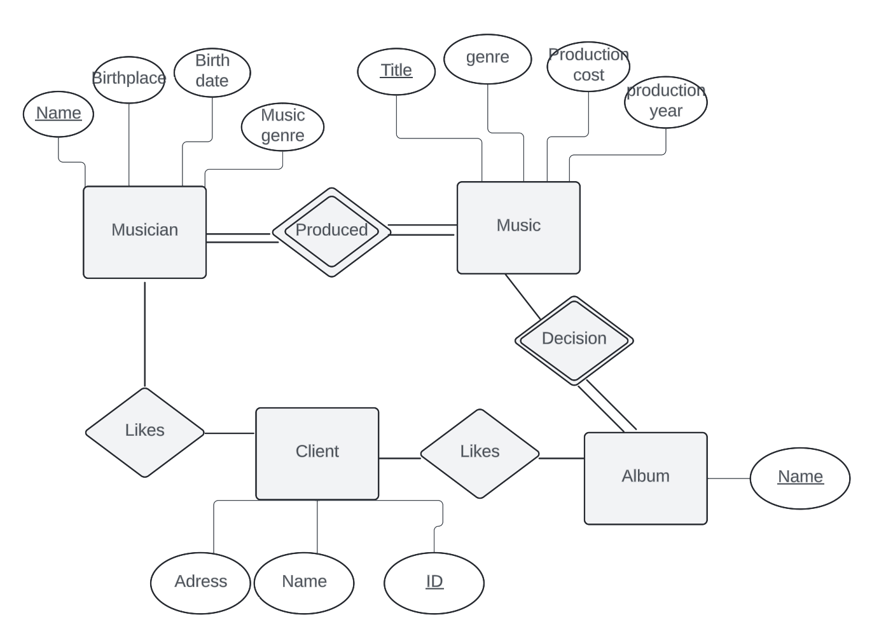

- Draw an EER diagram for a DVD rental COMPANY where people can borrow movie DVDs. The data requirements are summarised as follows:
  - The COMPANY has a unique name and manages several OFFICEs, each with an address and a unique number. An office can be either a MAIN OFFICE or a BRANCH OFFICE.
  - Each DVD is described by a unique code number, a title and a producer. A DVD has a COPY and the COMPANY may own one or more than one COPY of a DVD. The price that was paid for each COPY is recorded.
  - A BORROWER who has a unique ID can borrow a COPY of a DVD

